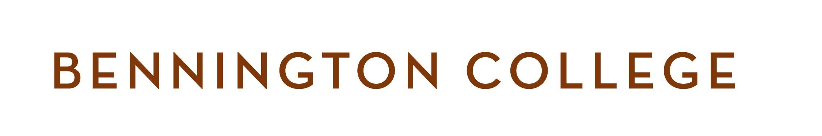
POSTBAC PRE-MED PROGRAM -- RENTAL AGREEMENT AND GUIDELINES
PARAN CREEK APARTMENTS - Full Year Rental

Agreement made on ____________________________________________ 2020, by and between Bennington
College, Bennington, VT 05201 (herein referred to as “the College”) and
_____________________________________________________ (herein referred to as “the Tenant”) whose
permanent address is:

________________________________________________________________

________________________________________________________________

________________________________________________________________

E-Mail: _____________________________________ Cell Phone: ______________________________

The College agrees to rent to the Tenant a room in apartment-style housing for the period from July 13, 2020 after 9:00 am, to May 31, 2021 at 12:00 pm. The rent for each term is: $1,195 for summer term, $3,590 for fall term, and $3,590 for spring term. You will be billed each term. A non-refundable payment of $400 is due, with a signed Rental Agreement, no later than June 1, 2020, in order to secure a room. Please note that the housing fee is subject to the refund policy (see College tuition and housing refund policy). The balance of summer rent is due by June 24, 2020. Fall rent is due in full on August 1, 2020 and Spring rent is due in full on December 23, 2020. Space is limited, so rooms will be reserved and assigned on a first-come, first-served basis.

The rented premises and implied responsibility for such premises consists of the rented room(s) and common space provided with each building.

The College agrees to provide electricity, cable TV, internet service, and heat. The College will not provide linen or maid service, private telephone service, nor dishes and kitchen utensils.

Rules and Regulations

The Tenant will observe and comply with, and the Tenant agrees, that all persons dwelling in or visiting in the premises, will observe and comply with all the rules and regulations of Bennington College, and such other and further rules and regulations as the College may from time to time deem needful, and prescribe the safety, care, and cleanliness of the building, and the preservation of good order therein as well as the comfort, quiet and convenience of other occupants of the building.

It is understood and agreed that the rented premises will not be shared, rented, or sublet to any person or persons not stated in this agreement without the written permission of the College.

The Tenant agrees to vacate the premises no later than May 31, 2021, at 12:00 pm, in order to allow the College adequate time to prepare for succeeding tenants.

Maintenance

The College agrees to make necessary repairs and replacements resulting from ordinary wear and tear. The Tenant agrees to pay for repairs and replacements made necessary by their intentional acts, carelessness, or negligence. He or she also agrees not to make structural changes in the rented premises without the written approval or the College. The Tenant of a house accepts responsibility for keeping the premises free of health and fire hazards, and for maintaining the good appearance of the grounds immediately adjoining the rented premises. When vacating these spaces, the Tenant agrees to remove all belongings and leave the premises “broom clean.”

I agree to comply with all of the aforementioned terms of this Agreement.

____________________________________________________ ___________________________
TENANT Signature Date

____________________________________________________ ___________________________
For BENNINGTON COLLEGE Date

Please make checks payable to Bennington College. Return the $400 non-refundable payment along with the signed agreement to:

Michelle Rollins
Business Office
Bennington College
One College Drive
Bennington, VT 05201

_____________________________________________________________________________________________
For Office Use Only

Date agreement received: ________________________ Room # assigned: ____________________________
Date payment received: _________________________ Check #: ___________________________________

Apply payment to: Program 114.4665

